PKU1200M new from HMI Systems

Learn more at www.hmisystems.net

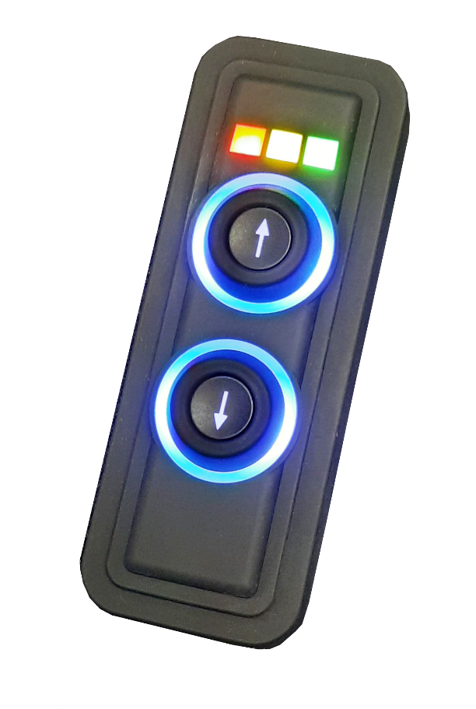
Standard Product Features

- 256 step brightness control for each color
- New LED visual effects (blink, pulse, spin, ripple, split)
- On/Off, momentary, toggle, scroll/step functions programmable for each key
- Autonomous operation (key press causes LED to change state without feedback from external device)
- NMEA200 bus compliant (support ISO requests, address claim, binary status 127501 and binary control 127502 messages)

- CAN Open
- J1939
- NMEA2000
- Free Software Utility

- Accessories Catalog
- Connector Options include Deutsch, Molex and more

Protocols & Accessories
with Designer Firmware Firmware
Improved Product Features
- Supply Voltage 12-24V
- Brighter LED’s
- Relegendable Buttons
- Multicolor indicator rings
- Sealed IP68
- Vertical or horizontal mount
- CRM, Designer, ECS firmware options
- Improved thermal dissipation
- Full color LED indicators including pure white
- Standard and custom legends (no mins, no set up fees)
- All LEDs active power consumption only 70 mA @ 12V
- Simplified CAN messaging using CANconnect software to control multiple LEDs within single message
- 3 extra status LEDs with independent control

1955 West State Rd 426 | Oviedo, FL 32765 | Tel: 407.359.8171 | Fax: 407.359.8170
info@hmisystems.net | www.hmisystems.net
